Logic Keywords

or & and True & False is & not

Goal: Determine if something is true or false.

Ex:

* 3 = 5 False
* NOT(3 = 5) True
* NOT (False = False) False
* NOT (True = False) True
* True OR False True
* True AND False False

We use an equal sign with integers and floats to determine if something is True or False. We double the equal sign (= =) with variable names.

*NOTE: If we use just a single equal sign (=) with a variable name, that is the same as assigning a value, i.e., yes = 3+5. The single equal sign assigns the value of 3+5 or 8 to the variable yes. If we are checking if the variable yes EQUALS 3+5, you need to type yes == 3+5. The second equal sign is like asking, “Is this variable assigned the value of 3+5?”*

* We use Logic FLOW operators to create a decision tree.
* When making a decision tree, we determine if a decision is true or false using logic operators.
  + Ex. Do you like pizza? Yes or No?
* If yes (is true), then do this
* If no (is true), then do that
* We code this using the IF statement.
  + IF statements are only going to check if something is true or false. They cannot evaluate.

IF XXX:

Do this

Elif YYY:

Do That

Else:

Do nothing

If functions check if the condition listed is true or false.

If the condition is true, it will do the action listed in the code and stop.

If the condition is false it will move to the next condition.

SYNTAX NOTE: action steps are indented under the code of the condition statement.

**SAMPLE CODE:**

Here is the decision tree we are going to use:

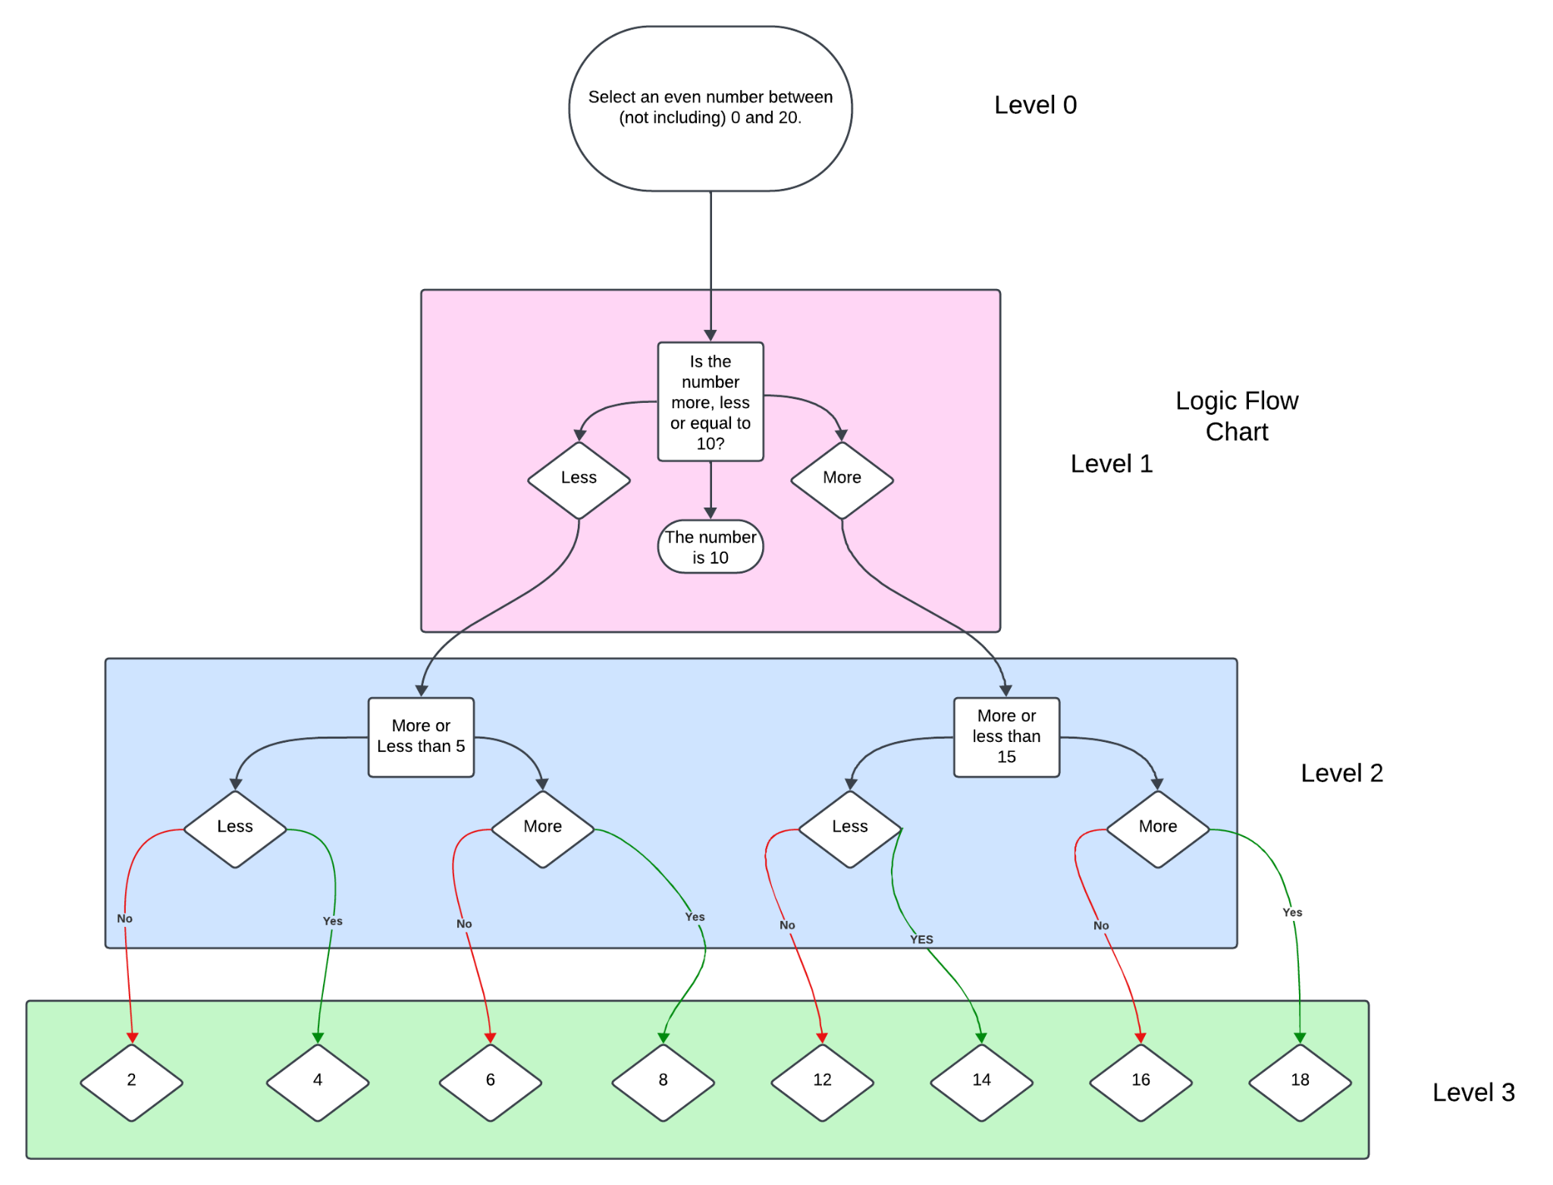

To create this decision tree, we use the following code:

*print("Let's play a game\nPick an even number between 0 and 20, but don't tell me. ")*

*guess_10 = input("Is your number more, less or equal to 10? ")*

*if guess_10 == "more":*

*guess_15 = input("Is your number more, less, than 15? ")*

*print(guess_2)*

*elif guess_10 =="less":*

*guess_5 = input("Is your number more, less than 5? ")*

*print(guess_3)*

*else:*

*print("Your number is 10.")*

*if guess_15 == "more":*

*guess_more_15 = input("Is your number more or less than 17? ")*

*else guess_15 =="less":*

*guess_less_15 = input("Is your number more, less, or equal to 13? ")*

*if guess_5 == "more":*

*guess_more_5 = input("Is your number more, less than 7? ")*

*else guess_5 =="less":*

*guess_less_5 = input("Is your number more, less than 3? ")*

*if guess_more_15 == "more":*

*print(“Your number is 18.”)*

*elif guess_more_15 =="less":*

*print(“Your number is 16.”)*

*if guess_less_15 == "more":*

*print(“Your number is 14.”)*

*elif guess_less_15 =="less":*

*print(“Your number is 12.”)*

*if guess_more_5 == "more":*

*print(“Your number is 8.”)*

*elif guess_more_5 =="less":*

*print(“Your number is 6.”)*

*if guess_less_5 == "more":*

*print(“Your number is 4.”)*

*elif guess_less_55 =="less":*

*print(“Your number is 2.”)*

**Assignment**:

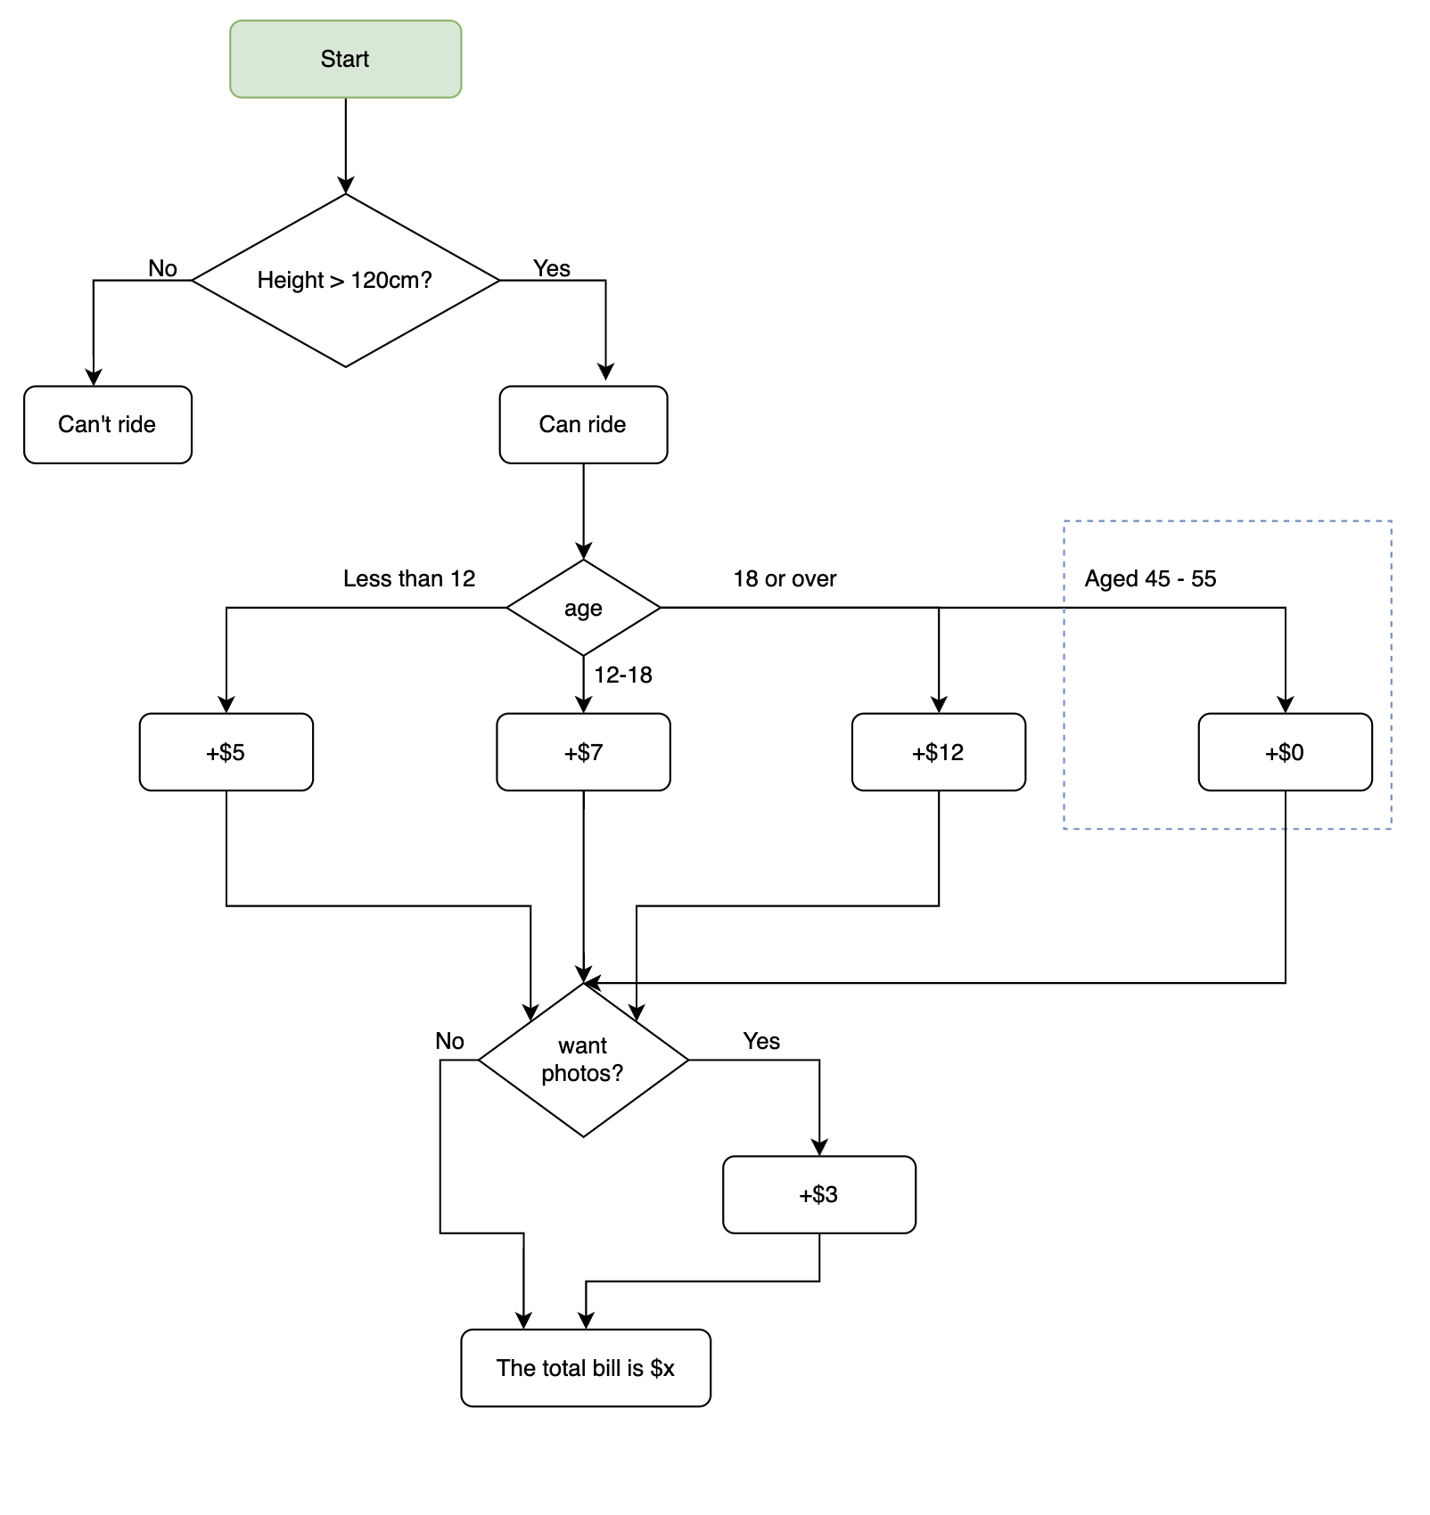

Use this diagram and what we learned about logic flow and control operators to create a ticketing calculator.

**Assessment**:

* Create your logic flow using IF statements.
* Submit your code in GitHub.
* Please submit the flow diagram in Lucid Chart with at least two options for each decision at each level and at least three levels.